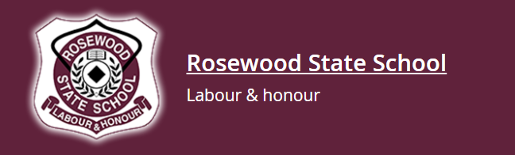

Prep at Rosewood State School
Starting Prep is a very special milestone for children and families. At Rosewood State School, we are proud to provide a nurturing, inclusive and high-expectation environment where every child is known, supported and encouraged to thrive from their very first day.
Prep is the foundation of your child’s learning journey, and we work in strong partnership with families to ensure a confident and successful start to school.

Our Rosewood Values in Prep
In Prep, students begin learning and living our school values every day:
- Be Respectful – using kind words and actions
- Be Responsible – looking after belongings and making good choices
- Bring Your Best – trying their hardest and showing perseverance
- Kindness is the Rosewood Way – caring for others and building positive friendships
These values guide our classroom expectations, behaviour support and daily interactions.

What Will My Child Learn in Prep?
Our Prep program builds strong foundations in:
- Early Literacy – letter sounds, reading, writing and oral language
- Early Numeracy – counting, number recognition, patterns and problem solving
- Social & Emotional Skills – managing feelings, working with others and building resilience
- Health & Physical Development – movement skills and wellbeing
- Creative Learning – art, music, play-based exploration and inquiry
Our teachers use explicit teaching, small group instruction, hands-on activities and purposeful play to support every learner. We provide differentiated learning so that each child is supported and challenged at their individual level.

A Supportive Start
We understand that starting school is a big step. At Rosewood, we focus on:
- Building strong relationships
- Creating predictable routines
- Supporting independence
- Celebrating effort and growth
- Working closely with families
Our team ensures every child feels safe, confident and ready to learn.

Is My Child Eligible for Prep?
Children can start Prep in Queensland if they turn 5 years old by 30 June in the year they begin school.
Information about starting Prep can be found on the QLD government site- https://www.qld.gov.au/education/earlychildhood/prep/enrolments

If you are unsure about eligibility, our school office is happy to assist.

How Families Can Prepare for Prep
You can support your child’s transition by encouraging them to:
- Recognise and attempt to write their name
- Follow simple instructions
- Share and take turns
- Pack and unpack their school bag
- Use the toilet independently
- Enjoy daily reading together
Most importantly, talk positively about school and build excitement about learning.

Enrolment Information
To enrol in Prep at Rosewood State School, families will need:
- Completed enrolment form
- Proof of age (birth certificate or passport)
- Proof of residential address
- Immunisation history statement
We welcome families to contact the office to arrange a school tour or attend a Prep information session.

At Rosewood State School, we are committed to equity and excellence for every learner. Prep is where confidence grows, friendships begin and a lifelong love of learning is nurtured.
We look forward to welcoming your family to our Rosewood community. 🌟

